ISO 22301 Compliance for Log360
Ensure operational resilience and ISO 22301 compliance with Log360.
Region: International | Type: Industry Standard, Operational Resilience | Category: Compliance | Pricing: Free

Overview
The ISO 22301 compliance extension in Log360 helps organizations meet ISO 22301:2019, the international standard for Business Continuity Management Systems (BCMS) published by ISO for all sectors requiring resilience against disruptive incidents by providing centralized log management, system availability monitoring, and continuity-focused audit reporting. The platform supports ISO 22301 requirements for business continuity infrastructure monitoring, backup and recovery operations, IT service availability, malware detection in recovery environments, disruptive incident detection, and continuity exercise audit evidence across cloud and on-premise environments.
For Business Continuity Infrastructure Monitoring, Log360 monitors backup infrastructure events, DR IAM activity, backup policy configurations, and DR licensing records to provide evidence of continuity infrastructure maintenance. To address Backup & Recovery Operations Monitoring, the platform monitors backup job execution, Windows backup and restore events, DR malware detection, and backup infrastructure events to verify recovery operation continuity. The extension also supports IT Service Availability Monitoring by providing capabilities that monitors Windows service status, system event logs, application crash events, and EventLog completeness to detect service failures impacting business continuity.

Key Features
- Malware & Threat Detection in Recovery Environments: Log360 monitors DR malware detection, antivirus threat alerts, consolidated threat detection, and anti-malware reports to protect backup and recovery infrastructure from compromise.
- Disruptive Incident Detection & Activation: Log360 monitors threat detection, firewall attack alerts, antivirus threats, system anomalies, and network attack reports to identify business-disrupting security incidents.
- Business Continuity Infrastructure Monitoring: Log360 monitors backup infrastructure events, DR IAM activity, backup policy configurations, and DR licensing records to provide evidence of continuity infrastructure maintenance.
- Backup & Recovery Operations Monitoring: Log360 monitors backup job execution, Windows backup and restore events, DR malware detection, and backup infrastructure events to verify recovery operation continuity.


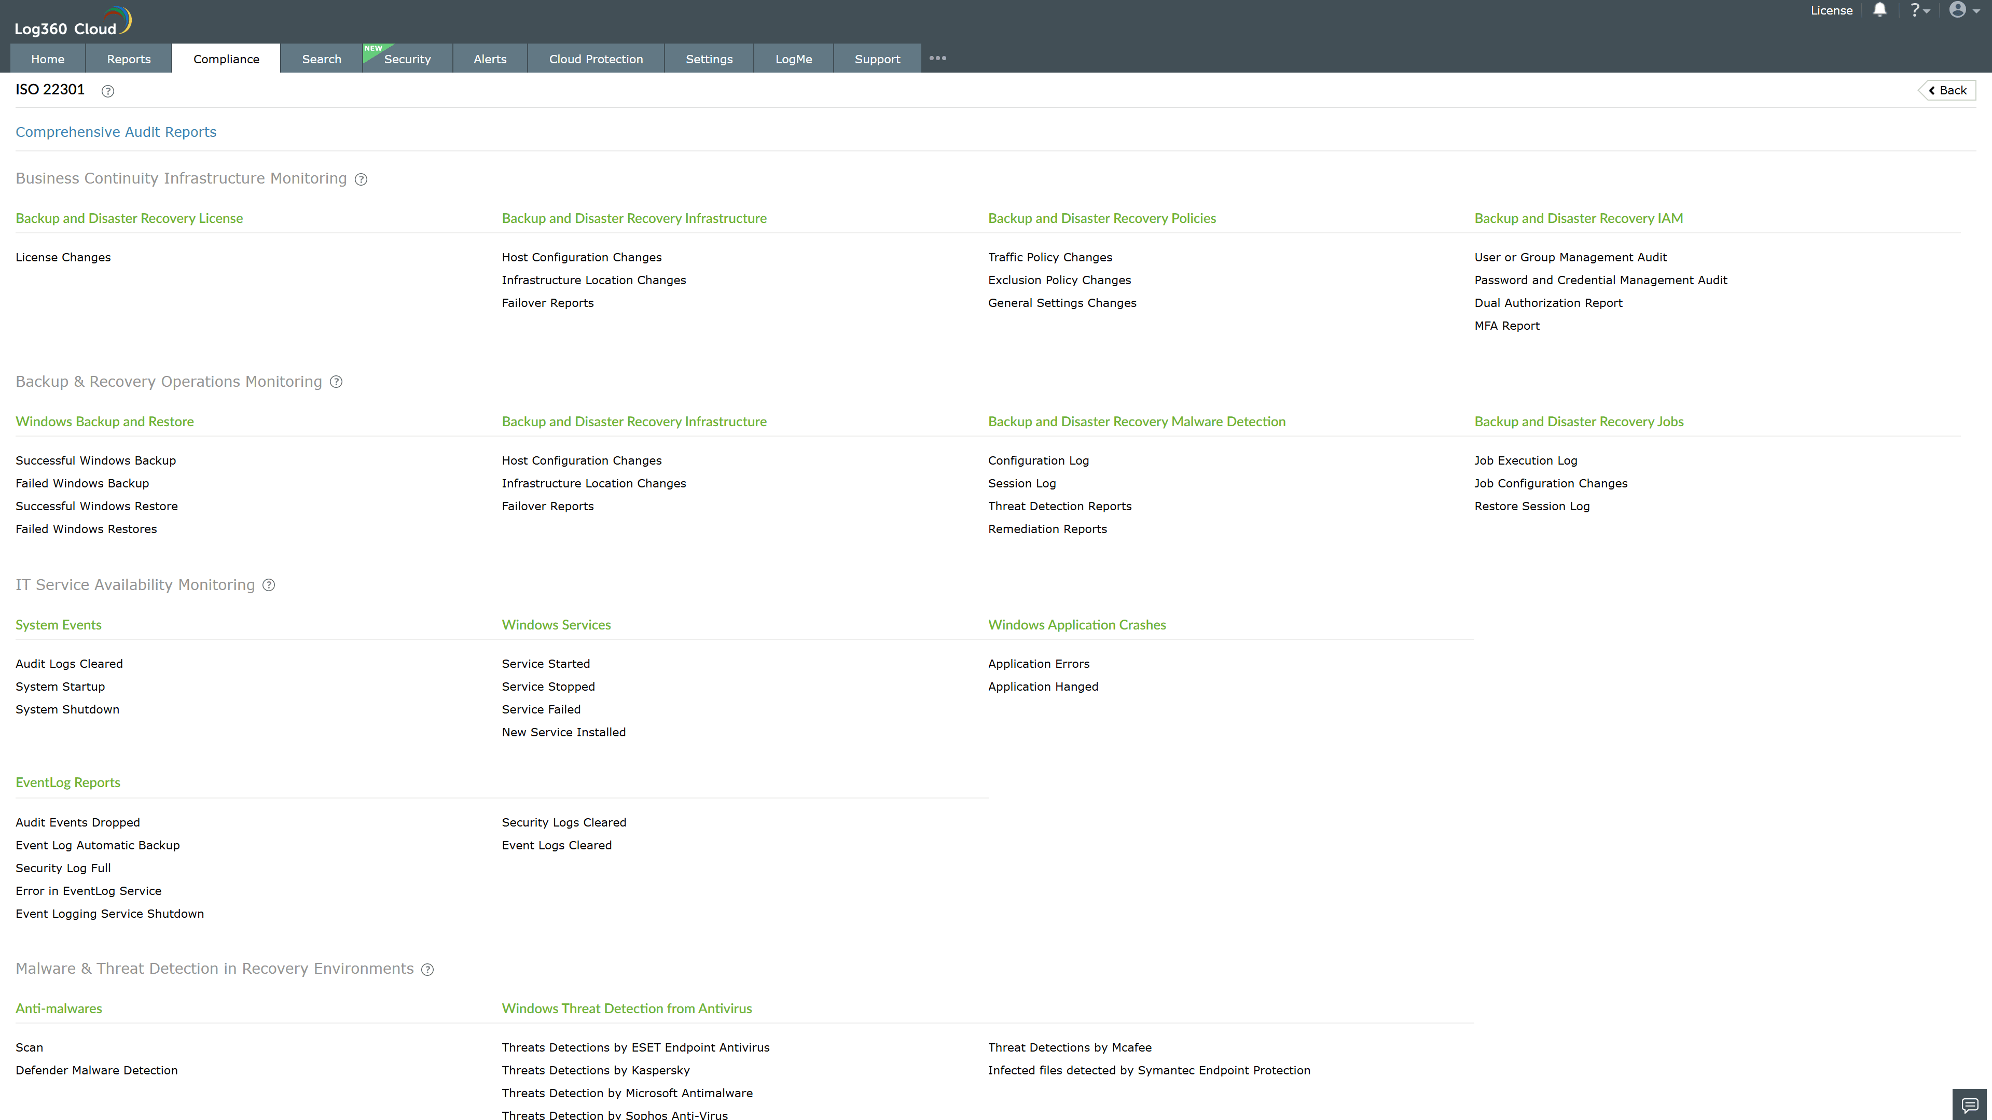
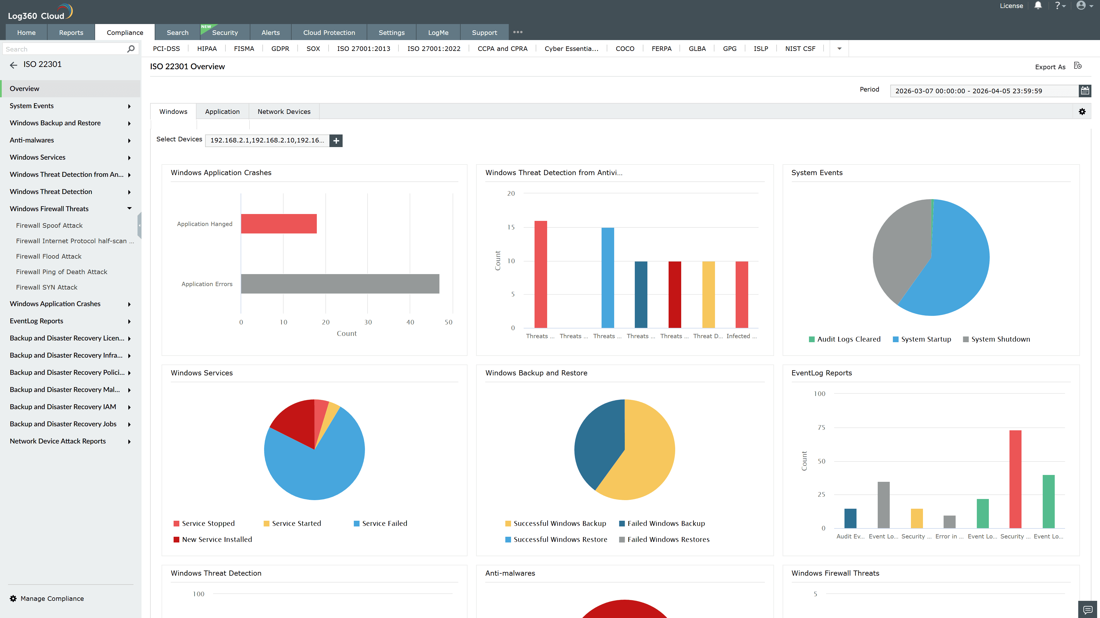
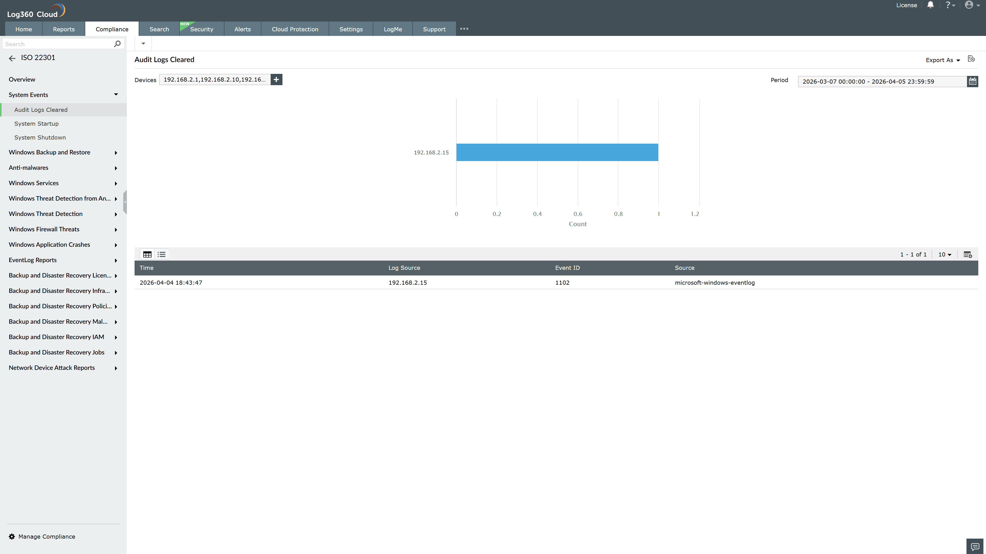
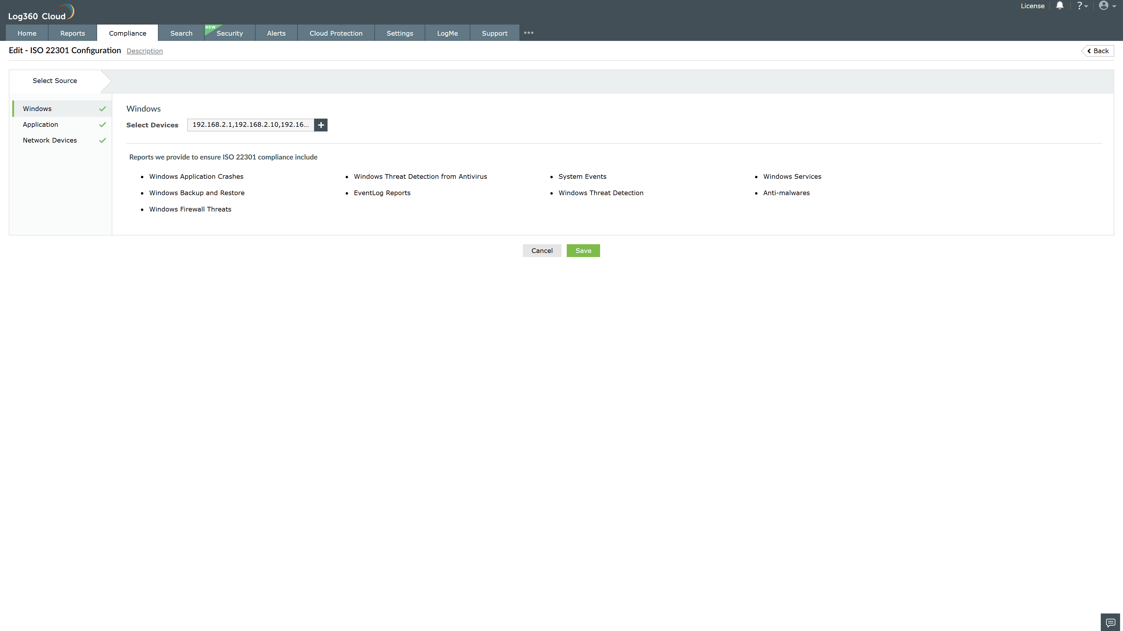
Valid Submission : Yes
Supported Editions : Free, Basic, Standard, Professional, MSSP
Help Document : https://www.manageengine.com/log-management/help/integrations/compliance-extensions.html
Help Video : Not provided
Tags : Log360, Compliance, Privacy monitoring, Data privacy, Regulatory compliance
Supported DCs : US, IN, JP, CA, AU, UK and EU
Privacy Policy:
Terms of Service:
Release Notes:
Predefined reports for the ISO 22301.

